**Continuity Homework**

1. Consider the functions *f* and *g* shown below. (The function *f* is shown on the left and the function *g* is shown on the right.)

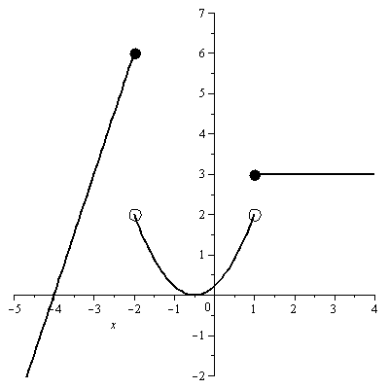 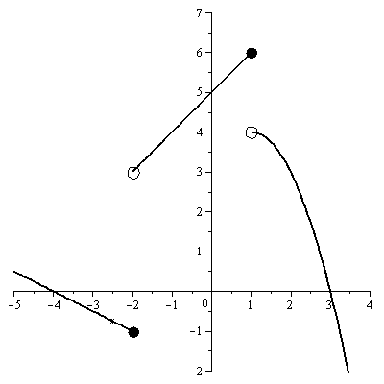

* 1. Is the function defined at *x* = -2? If so, what is *h* (-2)?
  2. Does exist? If so, what is it?
  3. Is the function (*f* +*g*) continuous at *x* = -2? Explain.
  4. Is the function continuous at x = 1? Explain.
  5. Is the function  continuous at x = -2? Explain.

1. Is it possible to find a constant *a* such that is continuous at *x* = *5*? Explain.
2. Is it possible to find constants *a* and *b* such that 

is continuous for all *x*? Explain.

1. Let .
   1. Find *a* so that *f*  is continuous at x = 2.
   2. For that value of *a*, is f differentiable at x = 2? Justify your answer using the definition of the derivative.